**Michael Hart**

**Database Management**

**Final Project**

**Business Specification Sheets**

|  |
| --- |
| **Rule Information**  **Rule Statement**: Every vice president must have a president.  **Constraint**:  **Type**: Database Oriented **Category**: Field Specific  Application Oriented Relationship Specific |
| **Structure Affect:**  Field Names: LecSSN  Table Names: |
| **Field Elements affected:**  Data Type Character Support  Data length Null Support  Decimal Points Range of Values  Key Type Default Value |
| **Relationship Characteristics Affected**  Degree of Participation Type of Relationship  Deletion Rule |
| **Actions Taken**  The LecSSN field’s Null Support must be changed from Null to Not Null. |

|  |
| --- |
| **Rule Information**  **Rule Statement**: Each student can only take up to 40 classes in total.  **Constraint**:  **Type**: Database Oriented **Category**: Field Specific  Application Oriented Relationship Specific |
| **Structure Affect:**  Field Names:  Table Names: Students, StudentClassID |
| **Field Elements affected:**  Data Type Character Support  Data length Null Support  Decimal Points Range of Values  Key Type Default Value |
| **Relationship Characteristics Affected**  Degree of Participation Type of Relationship  Deletion Rule |
| **Actions Taken**  The degree of participation for the StudentClasses table was changed to (0, 40). |

|  |
| --- |
| **Rule Information**  **Rule Statement**: A course can have no more than 5 pre-requisite courses.  **Constraint**:  **Type**: Database Oriented **Category**: Field Specific  Application Oriented Relationship Specific |
| **Structure Affect:**  Field Names:  Table Names: Courses, CoursePreReqs |
| **Field Elements affected:**  Data Type Character Support  Data length Null Support  Decimal Points Range of Values  Key Type Default Value |
| **Relationship Characteristics Affected**  Degree of Participation Type of Relationship  Deletion Rule |
| **Actions Taken**  The degree of participation for the CoursePreReq table was changed to (0, 5). |

|  |
| --- |
| **Rule Information**  **Rule Statement**: Each lecturer has to teach 1- 4 classes per semester.  **Constraint**:  **Type**: Database Oriented **Category**: Field Specific  Application Oriented Relationship Specific |
| **Structure Affect:**  Field Names:  Table Names: Lecturers, ScheduleOfCLasses |
| **Field Elements affected:**  Data Type Character Support  Data length Null Support  Decimal Points Range of Values  Key Type Default Value |
| **Relationship Characteristics Affected**  Degree of Participation Type of Relationship  Deletion Rule |
| **Actions Taken**  The degree of participation for the ScheduleOfClasses table was changed to (1, 4). |

|  |
| --- |
| **Rule Information**  **Rule Statement**: All students must currently live in the 50 states of the United States.  **Constraint**:  **Type**: Database Oriented **Category**: Field Specific  Application Oriented Relationship Specific |
| **Structure Affect:**  Field Names: StuState  Table Names: |
| **Field Elements affected:**  Data Type Character Support  Data length Null Support  Decimal Points Range of Values  Key Type Default Value |
| **Relationship Characteristics Affected**  Degree of Participation Type of Relationship  Deletion Rule |
| **Actions Taken**  The Range of Values for StuState was changed to the 50 states of the United States.  The Null Support was changed to Not Null. |

|  |
| --- |
| **Rule Information**  **Rule Statement**: If a faculty member leaves the college, the person will be deleted from the database, and all the classes he/she has taught will be marked as taught by “Unavailable”. (hint: deletion rule and default value)  **Constraint**:  **Type**: Database Oriented **Category**: Field Specific  Application Oriented Relationship Specific |
| **Structure Affect:**  Field Names: LecturerID, UserID, AccessLevelID, LogEntryID  Table Names: |
| **Field Elements affected:**  Data Type Character Support  Data length Null Support  Decimal Points Range of Values  Key Type Default Value |
| **Relationship Characteristics Affected**  Degree of Participation Type of Relationship  Deletion Rule |
| **Actions Taken**  The default value of LecturerID in the ScheduleOfClasses table will be set to “Unavailable” if the LecturerID is deleted.  The UserID, AccessLevelID, and LogEntryID associated with the LecturerID will be completely deleted. |

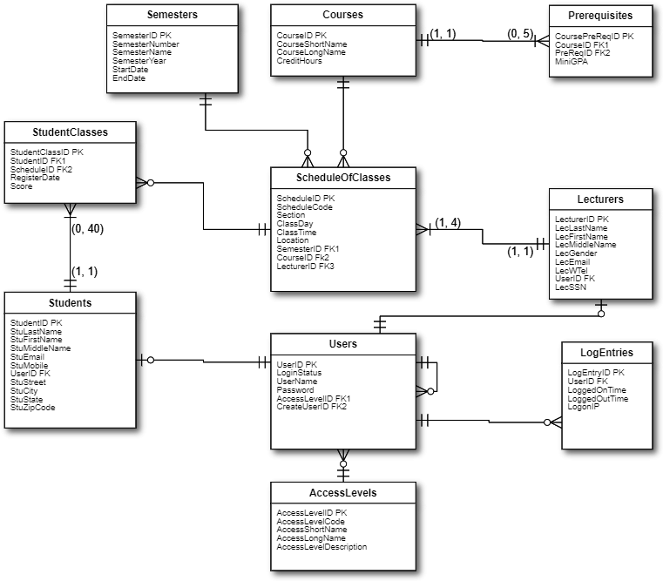

|  |  |  |  |  |  |  |  |  |  |
| --- | --- | --- | --- | --- | --- | --- | --- | --- | --- |
| Table | Field Name | Description | Key Type | Data Type | Length | Null Support | Index | Default Value | Value Range |
| CoursePreReqs | CoursePreReqID | Unique identification of each row | PK | int |  |  | Yes |  |  |
| CourseID | Unique course id | FK | Int |  |  | Yes |  |  |
| PrereqID | The id of a course as being prerequsites of that field | FK | Int |  |  | YES |  |  |
| MiniGPA | Minimum GPA required for prerequisite to be valid |  | Decimal | (3,2) | Null | No |  | 0.00-4.00 |
| Semesters | SemesterID | Primary key | PK | INT |  | Not null | Yes |  |  |
| SemesterNumber | The number code of the semester |  | varchar | 10 | Not null | Yes |  |  |
| SemesterName | Name of semester |  | Char | 10 | Not null | Yes |  |  |
| SemesterYear | Year of semester |  | Year | 4 | Not null | Yes |  |  |
| StartDate | Date of semester beginning |  | Date |  | Null | No |  |  |
| EndDate | Date of semester ending |  | Date |  | Null | No |  |  |
| Courses | CourseID | Primary key;ID of specific course | PK | INT |  | Not null | Yes |  |  |
| CouShortName | Short version of course name |  | Char | 9 | Null | No |  |  |
| CouLongName | Full version of course name |  | Varchar | 75 | Null | No |  |  |
| CourseDescription | Description of course |  | text |  | Null | No |  |  |
| CourseCredit | Number of credits |  | tinyint |  |  | no | 3 | 0-10 |
| StudentClasses | StudentClassID | Unique ID of the specific class that a student is in | PK | INT |  | Not null | Yes |  |  |
| StudentID | Unique ID of the student; FK | FK | INT |  | Not null | Yes |  |  |
| ScheduleID | Unique ID of the schedule; FK | FK | INT |  | Not null | Yes |  |  |
| RegisterDate | The date of class registration |  | date |  | Null | Yes |  |  |
| Score | The score that students get for each class |  | decimal | (4,1) | Nul | no |  | 0-100 |
| ScheduleOfClasses | ScheduleID | ID of the schedule | PK | INT |  | Not null |  |  |  |
| ScheduleCode | Code used for the schedule |  | Char | 10 | Not null |  |  |  |
| Section | Section of class |  | tinyint |  | Null |  |  |  |
| ClassDay | Day of class |  | Varchar | 14 | Null |  |  |  |
| ClassTime | Time of class |  | Time |  | Null |  |  |  |
| ClassLocation | Location of class |  | Varchar | 50 | Null |  |  |  |
| SemesterID | ID of semester | FK | INT |  | Not null | Yes |  |  |
| CourseID | ID of course | FK | INT |  | Not null | Yes |  |  |
| LecturerID | ID of Lecturer | FK | INT |  | Not null | Yes | Unavailable |  |
| Lecturers | LecturerID | ID of Lecturer | PK | INT |  | Not null | Yes |  |  |
| LecLastName | Surname of lecturer |  | Varchar | 25 | Not null | Yes |  |  |
| LecFirstName | First name of lecturer |  | Varchar | 25 | Not null | Yes |  |  |
| LecMiddleName | Middle name of lecturer |  | Varchar | 25 | Null | No |  |  |
| Gender | Gender of lecturer |  | Varchar | 10 | Null | No |  |  |
| LecEmail | College contact email for lecturer |  | Varchar | 50 | Not null | Yes |  |  |
| LecWTel | College work telephone for lecturer |  | Char | 10 | Null | Yes |  |  |
| UserID | UserID | FK | INT |  | Not null | Yes |  |  |
| LecSSN | Social security number |  | char | 9 | Not Null |  |  |  |
| Students | StudentID | ID of a student | PK | INT |  | Not null | Yes |  |  |
| StuLastName | Surname of student |  | Varchar | 25 | Not null | Yes |  |  |
| StuFirstName | First name of student |  | Varchar | 25 | Not null | Yes |  |  |
| StuMiddleName | Middle name of student |  | Varchar | 25 | Null | No |  |  |
| StuEmail | College email of student |  | Varchar | 50 | Not null | Yes |  |  |
| StuMobile | Mobile phone number of student |  | Char | 10 | Null | Yes |  |  |
| UserID | UsrID, FK | FK | INT |  | Not null | Yes |  |  |
| StuStreet | Street address of students |  | varchar | 100 |  | yes |  |  |
| StuCity | The city name of student address |  | varchar | 25 |  | yes |  |  |
| StuState | The state name student address |  | char | 2 | Not Null | yes |  | The 50 states of the USA. |
| Stuzipcode | Zipcode of student address |  | char | 6 |  | yes |  |  |
| AccessLevels | AccessLevelID | ID of Access Level | PK | INT |  | Not null | Yes |  |  |
| AccessLevelCode | Code for Specific Access level |  | varchar | 6 | Not null | Yes |  |  |
| AccessShortName | The short name for the access level |  | varchar | 15 | Not null | Yes |  |  |
| AccessLongName | The long name for the access level |  | varchar | 40 |  |  |  |  |
| AccessLevelDescription | Description of access level |  | Varchar | 255 | Not null | No |  |  |
| Users | UserID | ID to use on computer network | PK | INT |  | Not null | Yes |  |  |
| UserName | Name of user on computer network |  | Varchar | 25 | Not null | Yes |  |  |
| UserPassword | User's password for computer network |  | Char | 64 | Not null | No |  |  |
| LoginStatus | User is active in system or not |  | Char | 3 | Null | No |  |  |
| AccessLevelID | ID of access level | FK | INT |  | Not null | Yes |  |  |
| UserIDC | User ID which has been created by a user | FK | INT |  | Not null | Yes |  |  |
| LogEntries | LogEntryID | ID of when a user activity in the system | PK | INT |  | Not null | Yes |  |  |
| UserID | ID to use on computer network | FK | INT |  | Not null | Yes |  |  |
| LoggedOnTime | Time that a user logs on |  | Date time |  | Not null | Yes |  |  |
| LoggedOutTime | Time that a user logs out |  | Date time |  | Not null | Yes |  |  |
| LogonIP | IP address that a user logs in from |  | Varchar | 55 | Not null | Yes |  |  |

**Views**

**Question 2**: Suppose that the College will need to check frequently for the information listed below but without creating redundant information. In this case, creating a view for each of the above inquires is very helpful. **For each of the enquiries below, please provide a view diagram indicating which table(s) [only related tables] will be needed to create the view and which fields might be included in the view. You can find examples in the lecture slides.**

1. A phone number list of instructors so that the college can contact them? Please list the first and last name of the instructor, and the phone number.

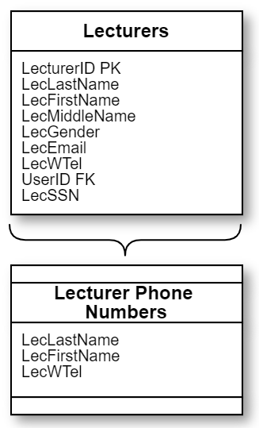

1. Which course has been taught by which lecturers? Please list the first and last name of each lecturer, and the number and long name of the course he/she has taught.

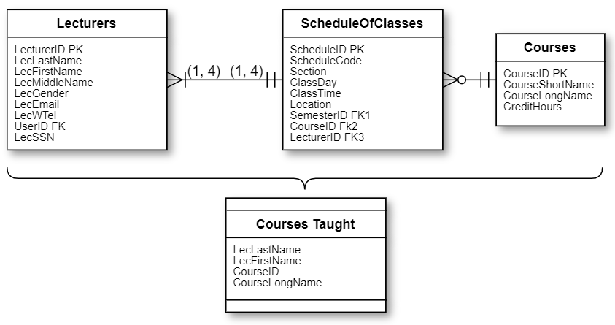

1. Which students register for each class (class roster)? Please list the course number, course long name, semester and the student first and last name.

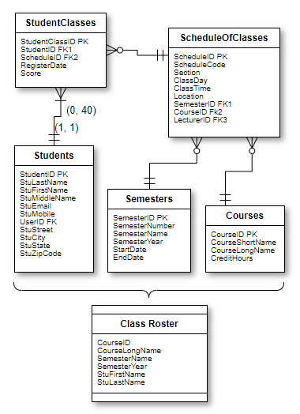

1. How many classes each student has taken? List student last name, first name, and the number of total classes each student has taken.

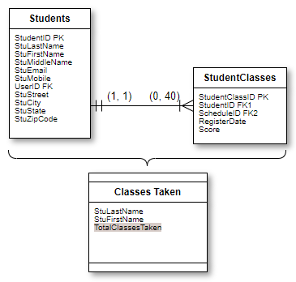

1. What is the current GPA of each student? Please list the first and last name of the student, and the average GPA he/she has obtained.

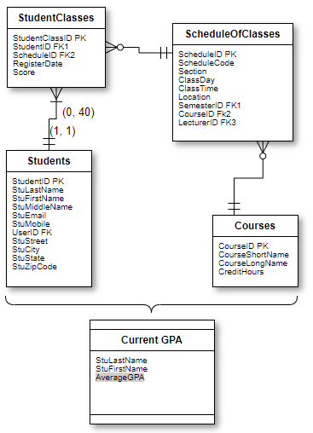

1. How many times a particular user has logged into the system? Please list the username and the number of times a user has logged into the system.

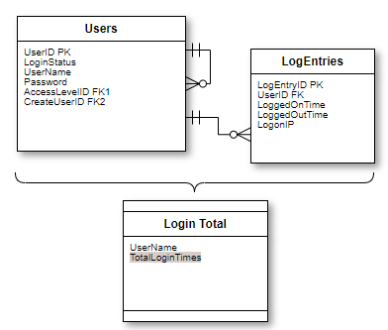

**Data Integrity Checklist**

**Question 3:** Checking data integrity after all the previous steps is critical. So please follow the “data integrity checklist” provided below to check the integrity of this database design regarding **field level, table level, relational level, business rule and views** by marking the **Status column** in the tables. This is a checklist compiled to you to review the data integrity of the database you’ve designed, you may also use this to review for your own projects in the future. If you notice something might be of a violation of data integrity, **please describe the problem here and fix them accordingly if needed.**

**Field Level Integrity**

|  |  |
| --- | --- |
| Status | Check Items |
| * OK | Field names has no space and some other special characters (hyphen and underscore is ok but not recommended); |
| * OK | * It represents a distinct characteristic of the subject of the table. |
| * OK | * It contains only a single value (not a multivalued field). |
| OK | It cannot be deconstructed into smaller components (not a multipart field). |
| * OK | * It does not contain a calculated or concatenated value. |
| * OK | * It is unique within the entire database structure. |
| * OK | * Field definitions are consistent throughout the database. |
| * OK | * The values of a field are consistent and valid (usually defined in field specification). |
| * OK | * Field names should NOT be reserved keywords for data types and SQL[1] |

**Table Level Integrity**

|  |  |
| --- | --- |
| Status | Check Items |
| OK | * Create a unique, descriptive name that is meaningful to the entire organization. |
| OK | * Create a name that accurately, clearly, and unambiguously identifies the subject of the table. |
| OK | * Use the minimum number of words necessary to convey the subject of the table. |
| OK | * Use the plural form of the table name. |
| OK | * There must be a primary key in each table |
| OK | * There are no duplicate records in a table. |
| OK | * The primary key exclusively identifies each record in a table. |
| OK | * Every primary key value is unique. |
| OK | * Primary key values are not null. |
| OK | * It does not contain multipart or multivalued fields. |
| OK | * It contains only an absolute minimum amount of redundant data. |
| OK | * Table names should not be reserved keywords for data types and SQL |

**Relationship Level Integrity**

|  |  |
| --- | --- |
| Status | Check Items |
| OK | * No table should be isolated in a database. |
| OK | If relationship exists between two tables, make sure FK(s) is in one of the tables. |
| OK | Only necessary relationships are built. |
| OK | Recursive relationships are identified if any. |
| OK | * There is a meaningful limit to the number of records that can be interrelated within the relationship (degree of participation). |
| OK | * You can insert new records into each table in a meaningful manner (made through field specification). |
| OK | * You can delete an existing record without producing any adverse effects (deletion rules are specified). |

**Business Rule Integrity**

|  |  |
| --- | --- |
| Status | Check Items |
| OK | You are sure that each rule imposes a meaningful constraint |
| OK | You’ve determined the proper category for the rule |
| OK | You’ve properly defined and established each rule |
| OK | You’ve modified the appropriate field specification elements or table relationship characteristics |
| OK | You’ve established the appropriate validation tables |
| OK | You’ve completed a Business Rule Specification Sheet for each rule. |

**Views Integrity**

|  |  |
| --- | --- |
| Status | Check Items |
| OK | Each view contains the base tables that necessary to provide the required information. |
| OK | You’ve assigned the appropriate fields to each view |
| OK | Each calculated field provides pertinent information or enhances the manner in which the view presents its data |
| OK | Each filter returns the appropriate set of records |
| OK | Each view has a view diagram |

1. Please find a list of reserved keywords for SQL here: http://dev.mysql.com/doc/refman/5.7/en/keywords.html